SIMATS ENGINEERING

ASSESSMENT TOOL 3

COURSE CODE:ITA0605 COURSE NAME: MACHINE LEARNING

COURSE OUTCOME COVERED

CO2: Neural Network Representation, Perceptron Model, Multilayer Perceptron’s, Backpropagation Algorithm, Deep Neural Networks, Genetic Algorithms, Hypothesis Space Search, Genetic Programming, Models of Evaluation and Learning (BL1, BL2)

Assessment Tool Weightage: 10%

QUESTIONS:15 Total Marks:25
Annexure A

DEBUGGING & OPTIMIZATION TASK QUESTIONS

Code of Conduct:

I _Yarrabolu Lasya(192524123) (Name / Reg No) certify that this submission is my original work and that I have adhered to the guidelines specified for this assessment.
I understand that any violation of academic integrity rules will result in disciplinary action.

Signature of the student: Y.Lasya

Annexure A

Short Answer Test

- A perceptron model is trained on a dataset that is known to be linearly separable, yet the algorithm fails to converge even after many iterations. Analyze the possible causes of this issue, including improper learning rate selection, incorrect weight initialization, bias handling errors, or flawed implementation of the update rule. Propose debugging strategies to identify the root cause and suggest optimization techniques to ensure faster and stable convergence.

A perceptron should converge when the dataset is linearly separable. If it does not converge, the problem may be in the learning rate, weight initialization, bias, or update rule.

POSSIBLE CAUSES:
LEARNING RATE: A very small learning rate makes learning slow, while a very large value can cause unstable updates.
WEIGHT INITIALIZATION: Incorrect or unsuitable initial weights may affect learning.
Bias error: If the bias is not included correctly, the decision boundary may not be positioned properly.
UPDATE RULE: The weight update formula may be implemented incorrectly.

Dataset:

Input 1 | Input 2 | Output
0 | 0 | 0
0 | 1 | 0
1 | 0 | 0
1  Program: | 1 | 1
import numpy as np X = np.array([
[0, 0],
[0, 1],
[1, 0],
[1, 1]
])
y = np.array([0, 0, 0, 1]) weights = np.zeros(2) bias = 0

learning_rate = 0.1
epochs = 20
print("Initial Weights:", weights) print("Initial Bias:", bias)
for epoch in range(epochs): errors = 0
for i in range(len(X)):
# Calculate weighted sum
z = np.dot(X[i], weights) + bias # Step activation function prediction = 1 if z >= 0 else 0
# Calculate error
error = y[i] - prediction
# Update weights and bias
weights = weights + learning_rate * error * X[i] bias = bias + learning_rate * error
if error != 0: errors += 1
print("Epoch:", epoch + 1, "Errors:", errors) # Stop if there are no errors
if errors == 0:
print("Perceptron converged!") break
print("\nFinal Weights:", weights) print("Final Bias:", bias)
# Testing print("\nPredictions:") for sample in X:
z = np.dot(sample, weights) + bias prediction = 1 if z >= 0 else 0 print(sample, "->", prediction)
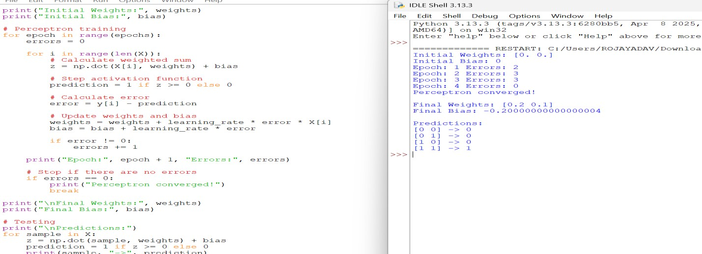

DEBUGGING STEPS:
- Check the weight and bias initialization.
- Verify the prediction and error calculation.
- Check the perceptron update rule:
w = w + η × error × x

- Print the weights and error after each iteration.
- Check whether the training data is actually linearly separable.

OPTIMIZATION TECHNIQUES:
- Select a suitable learning rate.
- Normalize or scale input features.
- Use a reasonable stopping condition.
- Shuffle training samples between epochs.
- Monitor the number of misclassified samples to verify convergence.
Thus, checking each component systematically can identify the implementation error and improve stable convergence

While training a multilayer perceptron using the backpropagation algorithm, the network exhibits slow convergence and gets stuck in local minima. Examine the potential reasons such as vanishing gradients, inappropriate activation functions, poor weight initialization, or suboptimal learning rates. Describe step-by-step debugging approaches to trace the issue and recommend optimization techniques like adaptive learning rates, normalization, or advanced optimizers to improve performance.

A multilayer perceptron may converge slowly because of vanishing gradients, unsuitable activation functions, poor initialization, or an inappropriate learning rate.

POSSIBLE CAUSES:
  - Vanishing gradients: Gradients become very small, especially with sigmoid or tanh in deep networks.
  - Activation function: Poor activation functions can slow learning.
  - Weight initialization: Very large or very small weights can make training difficult.
  - Learning rate: A very small rate causes slow learning, while a very large rate can make training unstable.

PROGRAM:
import numpy as np
from sklearn.datasets import load_iris
from sklearn.model_selection import train_test_split from sklearn.preprocessing import StandardScaler from sklearn.neural_network import MLPClassifier from sklearn.metrics import accuracy_score
data = load_iris()
X = data.data y = data.target

X_train, X_test, y_train, y_test = train_test_split( X, y, test_size=0.2, random_state=42
)
scaler = StandardScaler()
X_train = scaler.fit_transform(X_train) X_test = scaler.transform(X_test) model = MLPClassifier(
hidden_layer_sizes=(10, 10), activation='relu', solver='adam', learning_rate_init=0.001, max_iter=500, random_state=42
)
model.fit(X_train, y_train) y_pred = model.predict(X_test)
accuracy = accuracy_score(y_test, y_pred) print("MLP Training Completed") print("Number of Iterations:", model.n_iter_) print("Test Accuracy:", accuracy)
if model.n_iter_ >= 500:
print("Warning: Model may be converging slowly.") else:
print("Model converged within the given iterations.")
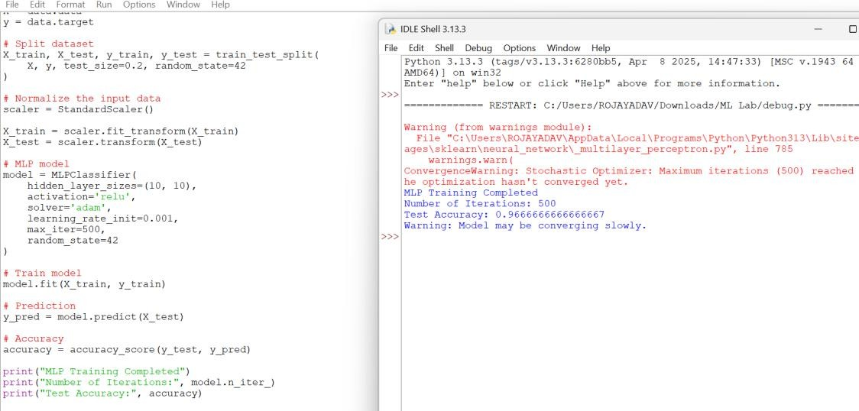

DEBUGGING STEPS:
- Check the training and validation loss after every epoch.
- Monitor the magnitude of gradients in each layer.
- Check whether the activation functions are suitable.
- Verify the weight initialization method.
- Test different learning rates and compare convergence.

OPTIMIZATION TECHNIQUES:
  - Use ReLU activation in hidden layers.
  - Normalize the input data.

  - Use He or Xavier initialization.
  - Use adaptive optimizers such as Adam.
  - Use learning-rate scheduling.
  - Apply batch normalization when appropriate.
These methods help the network learn faster, avoid unstable training, and improve overall performance.

A genetic algorithm designed for hypothesis space search is producing inconsistent and suboptimal solutions across multiple runs. Investigate possible issues such as improper encoding of chromosomes, incorrect fitness function design, premature convergence, or lack of diversity in the population. Explain how to debug these problems systematically and suggest optimization strategies like mutation tuning, selection pressure adjustment, and elitism to enhance solution quality and
convergence speed.
A genetic algorithm can produce different results in different runs because it uses random initialization and genetic operations. Poor chromosome encoding, fitness functions, or lack of population diversity can also reduce solution quality.

POSSIBLE CAUSES
  - Improper chromosome encoding: The chromosome may not correctly represent the possible solutions.
  - Incorrect fitness function: A poorly designed fitness function may reward unsuitable solutions.
  - Premature convergence: The population may become too similar too early.
  - Low diversity: Insufficient mutation or excessive selection pressure can reduce diversity

PROGRAM:
import random target = "10101010"
population_size = 10
mutation_rate = 0.1
generations = 30
def create_chromosome():
return ''.join(random.choice("01") for _ in range(len(target))) def fitness(chromosome):
return sum(
1 for a, b in zip(chromosome, target) if a == b
)
def selection(population): population.sort(key=fitness, reverse=True) return population[:2]

def crossover(parent1, parent2):
point = random.randint(1, len(target) - 1) child1 = parent1[:point] + parent2[point:] child2 = parent2[:point] + parent1[point:] return child1, child2
def mutation(chromosome): chromosome = list(chromosome) for i in range(len(chromosome)):
if random.random() < mutation_rate:
chromosome[i] = '1' if chromosome[i] == '0' else '0' return ''.join(chromosome)
population = [ create_chromosome()
for _ in range(population_size)
]
for generation in range(generations): best = max(population, key=fitness) print(
"Generation:", generation + 1, "Best:", best,
"Fitness:", fitness(best)
)
if best == target:
print("\nTarget solution found!") break
parents = selection(population) new_population = parents.copy()
while len(new_population) < population_size: parent1 = random.choice(parents)
parent2 = random.choice(parents)
child1, child2 = crossover(parent1, parent2) child1 = mutation(child1)
child2 = mutation(child2) new_population.append(child1)
if len(new_population) < population_size: new_population.append(child2)
population = new_population print("\nFinal Best Solution:")
best = max(population, key=fitness) print("Chromosome:", best) print("Fitness:", fitness(best))
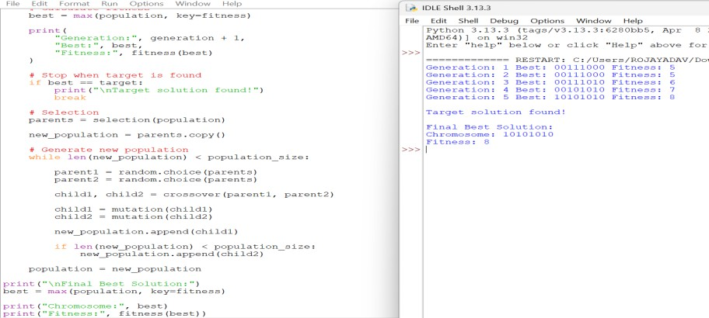

DEBUGGING STEPS:

  - Verify that chromosome encoding represents valid solutions.
  - Test the fitness function using known sample solutions.
  - Monitor the best and average fitness in every generation.
  - Check the mutation and crossover operations.
  - Run the algorithm with different random seeds and compare results.

OPTIMIZATION TECHNIQUES
  - Adjust the mutation rate to maintain diversity.
  - Reduce excessive selection pressure.
  - Use suitable crossover methods.
  - Apply elitism to preserve the best solutions.
  - Maintain a sufficiently large population.
  - Use multiple runs and compare average performance.
These techniques improve population diversity, solution quality, and convergence speed.

A deep neural network combined with genetic programming is used for solving a complex prediction problem, but it suffers from overfitting and high
computational cost. Identify debugging steps to analyze issues related to model complexity, over-parameterization, and insufficient training data. Propose optimization techniques such as regularization, dropout, pruning, and efficient evaluation models to balance accuracy and computational efficiency while improving generalization capability.

A deep neural network combined with genetic programming can become computationally expensive because both models may have high complexity. Overfitting occurs when the model learns the training data too closely and performs poorly on unseen data.

POSSIBLE CAUSES:
  - Too many network layers and parameters.
  - Complex genetic-programming expressions.
  - Insufficient training data.
  - Excessive model evaluation during genetic search.
  - Lack of regularization

PROGRAM:
import numpy as np
from sklearn.datasets import load_digits

from sklearn.model_selection import train_test_split from sklearn.preprocessing import StandardScaler from sklearn.neural_network import MLPClassifier from sklearn.metrics import accuracy_score
data = load_digits()
X = data.data y = data.target
X_train, X_test, y_train, y_test = train_test_split( X, y,
test_size=0.2, random_state=42, stratify=y
)
scaler = StandardScaler()
X_train = scaler.fit_transform(X_train) X_test = scaler.transform(X_test) model = MLPClassifier(
hidden_layer_sizes=(64, 32), activation='relu', solver='adam',
alpha=0.001, # L2 regularization early_stopping=True, # Prevent overfitting validation_fraction=0.15,
max_iter=300, random_state=42
)
model.fit(X_train, y_train) train_pred = model.predict(X_train) test_pred = model.predict(X_test)
train_accuracy = accuracy_score(y_train, train_pred) test_accuracy = accuracy_score(y_test, test_pred) print("Training Accuracy:", train_accuracy) print("Testing Accuracy:", test_accuracy)
difference = train_accuracy - test_accuracy

print("Accuracy Difference:", difference) if difference > 0.10:
print("Warning: Possible overfitting") else:
print("Overfitting is under control")

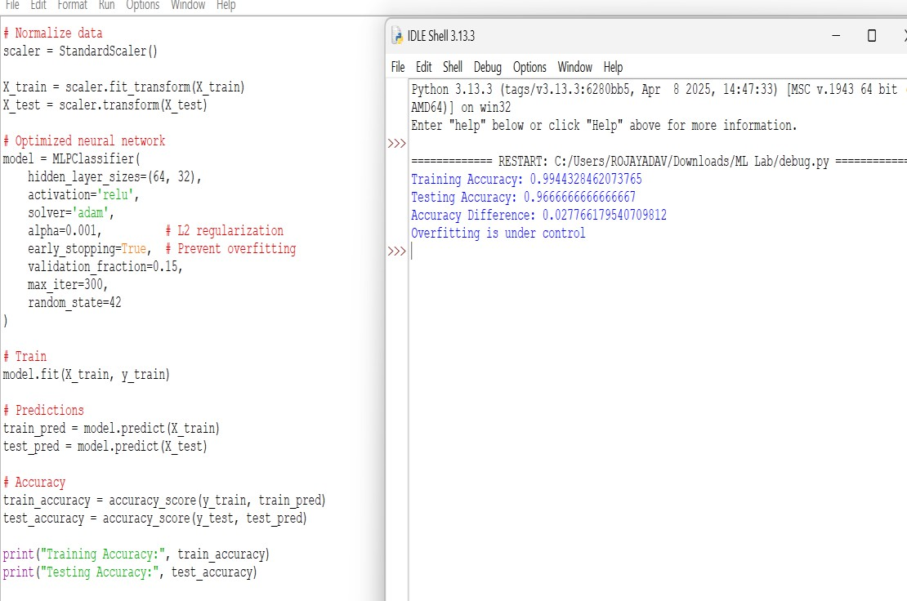

DEBUGGING STEPS:
  - Compare training and validation accuracy/loss.
  - Check the number of network parameters.
  - Identify unnecessarily complex genetic-programming expressions.
  - Monitor computational time for each generation.
  - Check whether the training dataset is sufficiently large.

OPTIMIZATION TECHNIQUES:
  - Use L1/L2 regularization to reduce overfitting.
  - Apply dropout in the neural network.
  - Use pruning to remove unnecessary connections or structures.
  - Reduce the number of layers or parameters.
  - Use early stopping.
  - Use efficient fitness evaluation and avoid evaluating unnecessarily complex solutions
Therefore, reducing model complexity while using regularization can improve generalization and reduce computational cost.

A decision tree model trained on a large dataset shows high accuracy on training data but poor performance on unseen data. Analyze possible causes such as overfitting, deep tree structure, or noisy data. Propose debugging steps and optimization methods like pruning, cross-validation, and feature selection to
improve generalization.

This problem is mainly caused by overfitting. A decision tree that is too deep can memorize the training data, including noise, instead of learning general patterns.

POSSIBLE CAUSES:
  - Very deep tree structure.
  - Too many branches and leaf nodes.
  - Noisy or irrelevant features.
  - Insufficient control over tree complexity.
  - Training data may not represent unseen data well.

PROGRAM:
from sklearn.datasets import load_iris
from sklearn.model_selection import train_test_split, cross_val_score from sklearn.tree import DecisionTreeClassifier
from sklearn.metrics import accuracy_score data = load_iris()
X = data.data y = data.target
X_train, X_test, y_train, y_test = train_test_split( X, y,
test_size=0.2, random_state=42, stratify=y
)
deep_tree = DecisionTreeClassifier( max_depth=None, random_state=42
)
deep_tree.fit(X_train, y_train) train_pred = deep_tree.predict(X_train) test_pred = deep_tree.predict(X_test)
train_accuracy = accuracy_score(y_train, train_pred) test_accuracy = accuracy_score(y_test, test_pred) print("Before Optimization")
print("Training Accuracy:", train_accuracy) print("Testing Accuracy:", test_accuracy) optimized_tree = DecisionTreeClassifier(
max_depth=3, min_samples_split=5, min_samples_leaf=2, random_state=42
)
optimized_tree.fit(X_train, y_train) train_pred2 = optimized_tree.predict(X_train) test_pred2 = optimized_tree.predict(X_test)
train_accuracy2 = accuracy_score(y_train, train_pred2) test_accuracy2 = accuracy_score(y_test, test_pred2) print("\nAfter Optimization")
print("Training Accuracy:", train_accuracy2) print("Testing Accuracy:", test_accuracy2) scores = cross_val_score(

optimized_tree, X,
y, cv=5
)
print("\n5-Fold Cross Validation Scores:", scores) print("Average CV Accuracy:", scores.mean())
if train_accuracy - test_accuracy > 0.10: print("\nWarning: Possible overfitting in deep tree.")
else:
print("\nNo major overfitting detected.")
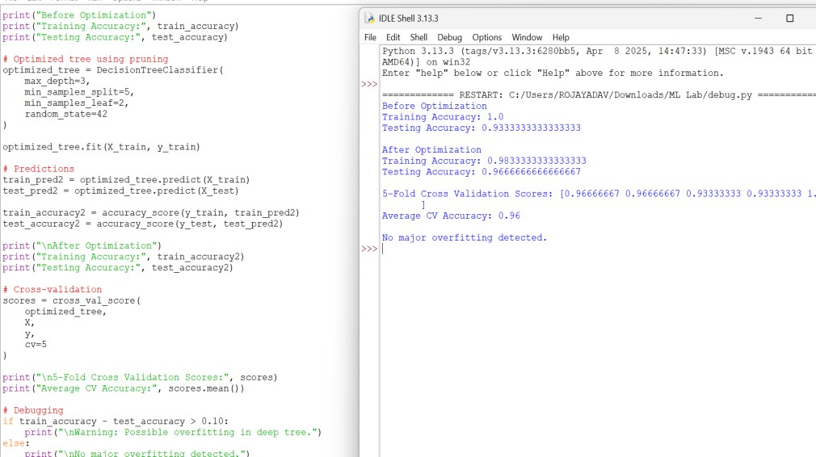

DEBUGGING STEPS:
  - Compare training accuracy with validation/test accuracy.
  - Check the depth and number of nodes in the tree.
  - Identify irrelevant or noisy features.
  - Use cross-validation to evaluate generalization.
  - Examine whether the tree is creating very small leaf nodes.

OPTIMIZATION TECHNIQUES:
  - Apply pre-pruning using maximum depth and minimum samples per leaf.
  - Apply post-pruning to remove unnecessary branches.
  - Use cross-validation to select suitable parameters.
  - Perform feature selection to remove irrelevant features.
  - Remove or handle noisy data where appropriate.

RUBRICS FOR CALCULATION

Criteria | Weightage | Level 4 –  Exemplary (5 Marks) | Level 3 –  Proficient (4 Marks) | Level 2 –  Developing (2–3 Marks) | Level 1 –  Beginning (0–1 Mark)
Conceptual Understanding | 30 | Demonstrates clear and complete understanding of the concept | Good understanding  with minor gaps | Basic understanding with some misconceptions | Poor or incorrect understanding
Accuracy of Answer | 20 | Completely correct answer with no errors | Mostly correct with minor errors | Partially correct with noticeable  errors | Incorrect or irrelevant answer
Application of Knowledge | 30 | Correctly applies concepts to solve the question/problem | Applies concepts  with minor mistakes | Limited or partially correct application | No or incorrect application
Completeness of Response | 10 | Covers all required parts of the question | Covers most parts with minor omissions | Covers only some parts | Incomplete or missing response
Clarity & Presentation | 10 | Clear, concise, and well-organized answer | Understandable with minor  issues | Somewhat unclear or poorly structured | Difficult  to understand

